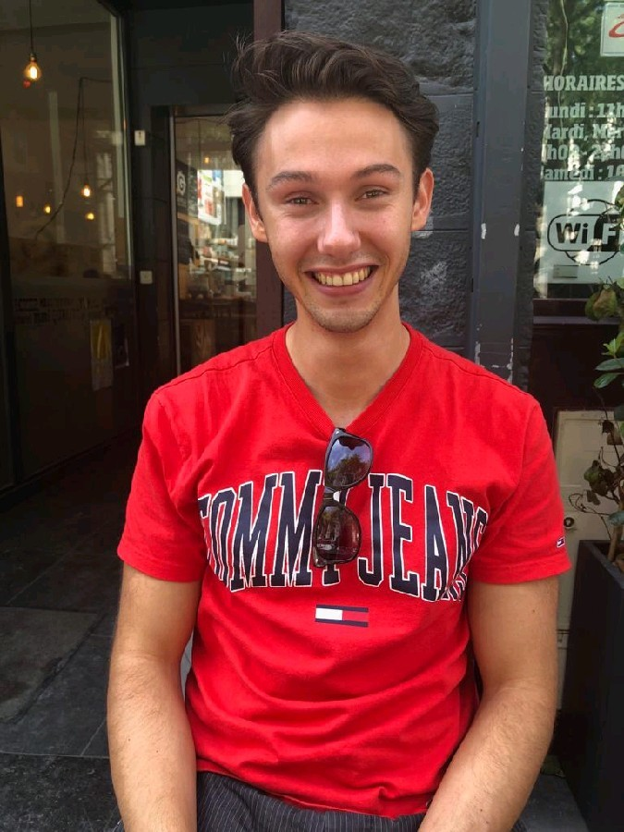  
Jasper Sparla

Beth van de Rijtlaan 4, Nuenen, 5673AB

06 27123300 | jasper.sparla@outlook.com| 26-04-1995

https://www.linkedin.com/in/jasper-sparla/

# profile

I’ve always had a big interest in biology, chemistry and medicine. The biomedical engineering study at the TU/e fit these interests perfectly. I enjoy interacting with other people and helping friends and colleagues.

# Education

Master biomedical engineering Eindhoven

Technical University of Eindhoven September 2016-2019

**Master thesis:** Studying the effects of active fibroblast migration influenced by conditioned macrophage media. Macrophages were seeded on PCL-bisurea scaffolds and differentiated via strain.

**Master specialization:** Stem cells, cell mechanobiology, regeneration   
**Skills used:**  Cell culturing/differentiation, confocal/fluorescence microscopy, immunofluorescence, qPCR, Electrospinning, Matlab

Bachelor biomedical engineering Eindhoven

Technical University of Eindhoven September 2013- June 2016

**Bachelor end project:** Creation of new bifunctional ureidopyrimidinone (UPY)-based hydrogels.  
**Skills used:** H-NMR, IR-spectroscopy, dynamic light scattering (DLS), pH-chemistry

**VWO diploma** EindhovenLorentz Casimir Lyceum September 2007- July 2013

# Experience

InternshipNijmegen

HCM Medical August 2019 - November 2019  
  
External internship at a company during my master phase. At HCM medical I got a closer look at businesses in the medical device sector. I researched the effects of using a new decellularization method using supercritical CO2.

**Skills used:** DNA-measurements, freeze-drying, sterilization, scCO2

Brand promotion Eindhoven

Opvallers August 2016 – August 2019

Increase brand familiarity by handing out products or flyers to people in supermarkets or on the street. Whilst handing out products or flyers, make small talk and tell them about the newest product.

Employee, cashier Nuenen

HEMA November 2015 - June 2017

Variety of responsibilities , including helping customers in the store, working behind the cash registry and restocking supplies.

# Skills

**Languages**  **Software/programming languages**

Dutch: Native language Matlab

English: Very proficient Python, HTML/CSS/Javascript, C#.NET, ASP MVC  
German: Intermediate Word, Excel, PowerPoint etc.

French: Basics RCmdr, SQL

**Lab-skills:** Wide variety of lab skills including but not limited to:

Cell culturing/differentiation, ELISA (Basic), confocal/fluorescence microscopy, immunofluorescence, qPCR, Electrospinning, H-NMR, IR-spectroscopy, dynamic light scattering (DLS), pH-chemistry, etc.

# Hobbies & interests

* Tennis, training and competition
* Going to PSV matches
* Playing acoustic and electric guitar
* Fitness